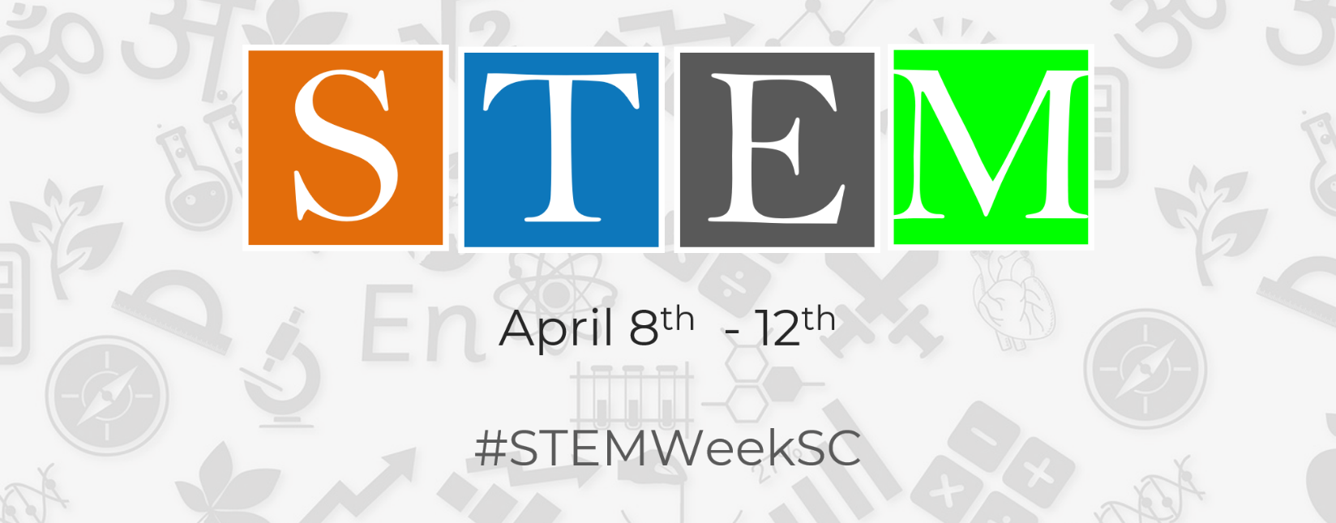

Show Us Your STEM! Educator Resources

STEM Lessons

The SC Standards Support System (S³), a collection of high-quality, professionally developed lessons originally written to correlate to the 2005 SC Science Standards and the 2007 SC Mathematics standards have been revamped.
This updated collection of lessons, aligns with the latest SC standards, were developed by S²TEM Centers SC and offered as free, downloadable lessons. These introductory lessons are designed to serve as supplemental teacher resources—not the primary curriculum.

They include:
- Individual math and science lessons.
- Grade 1 Unit: Plants
- Grade 3 Unit: Properties and Changes in Matter with Measurement and Data Analysis
- Grade 8 Unit - Graphing in Math and Science: Linear Data and Force & Motion
- High School Unit - One Dimensional Kinematics: Modeling Motion – Physics and Algebra 2

STE(A)M Activity Resources
- https://imagineupstate.org/stem-activities/
- https://www.nasa.gov/audience/foreducators/index.html
- https://www.teachengineering.org/
- http://discovere.org/our-activities
- https://www.howstuffworks.com/
- https://globaldigitalcitizen.org/36-stem-project-based-learning-activities
- https://babbledabbledo.com/25-steam-projects-for-kids/
- http://www.eie.org
- http://www.pbskids.org
- https://www.playdoughtoplato.com
- https://elementalscience.com/blogs/science-activities?page=1
- https://leftbraincraftbrain.com/28-days-hands-on-stem-activities-kids

